Nom : ……………………………. Date : …………………………….
CP

Lecture
Fiche
L8

http://www.i-profs.fr

Mots fléchés [f] f-ff-ph



 |  |  |  |  | 
 |  |  |  |  |  |  |  |  | 
 |  |  | 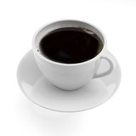
 |  |  |  |  |  |  | 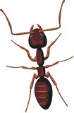
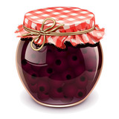
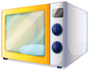

Nom : ……………………………. Date : …………………………….
CP

Lecture
Fiche
L8

Mots fléchés [f] f-ff-ph

Café – phoque – coffre – pharmacie – fourmi – confiture - four

http://www.i-profs.fr

Nom : ……………………………. Date : …………………………….
CP

Lecture
Fiche
L8

Mots fléchés [f] f-ff-ph

 |  |  |  |  |  | p
 |  |  |  |  |  | h
 |  |  |  |  | c | a | f | é |  | c
 |  |  |  |  |  | r |  |  |  | o
 |  |  |  |  |  | m |  |  |  | f
 |  |  | p |  |  | a |  | f |  | f
 |  |  | h |  |  | c |  | o |  | r
 |  | c | o | n | f | i | t | u | r | e
 |  |  | q |  |  | e |  | r
 | f | o | u | r |  |  |  | m |  | http://www.i-profs.fr
 |  |  | e |  |  |  |  | i

